*Florida International University*

*School of Computing and Information Sciences*

Feature Document

User Story ID 207

**Team Member(s):** Jordan Laing, Galo Romero

**Project:** Biosensing 2.0

**Product Owner(s)**: Shekhar Bhansali, Yogeswaran Umasankar

**Mentor(s)**: Vishal Chopade, Apurva Sonawane

**Instructor**: Masoud Sadjadi

**User Story:** Integrate MS SQL Server

### **Description:**

* As a user, I want to be able to send data that the app collects to the server.

### **Acceptance Criteria:**

1. The app connects to a database running on a locally hosted SQL Server
2. The app successfully sends data to the database

**Use Case:**

* **I**D: 207-01 - Push temperature data to database
* **Actor:** User
* **Entry Condition:** This use case starts when the user opens the app.
* **Flow of Events:**
  + The user opens the app.
  + The system begins monitoring the sensors in the biosensing device.
  + The system sends the current temperature to the database
  + When the temperature changes, the system sends the new one to the database
  + The user closes the app.
* **Exit Condition:** This use case ends when the user closes the app.

**Use Case Diagram**

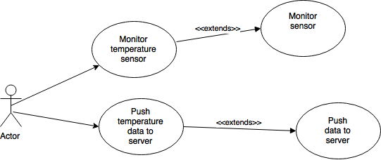

**Sequence Diagram**

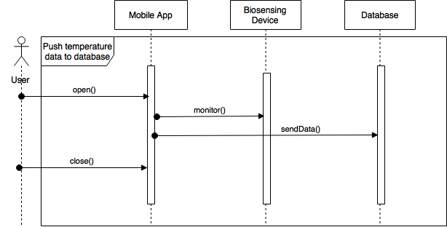

**Testing**

* Test Case ID: 207-001
* Purpose: To test if the mobile app can send temperature data to the server.
* Preconditions:
  + Android application package installed on mobile device
  + SQL Server running on same local network as mobile device
* Expected Result: Whenever the app detects a temperature change, it sends the current temperature to the server, which adds a timestamp to it
* Actual Result: The app fails to start successfully (android version problem)

**User Guide**

In this particular case, the only actions the user must take are opening the app and selecting the device the app will connect to. Once the user has selected the biosensing device, the app will connect to it using Bluetooth and begin monitoring the sensors the device contains. At the beginning, and whenever the sensor detects a change in temperature, the device sends the temperature data to the server.

